**Project Development Phase**

**Sprint – 1**

|  |  |
| --- | --- |
| **Team ID** | **PNT2022TMID50805** |
| **Project Name** | **Hazardous Area Monitoring for Industrial Plant powered by IoT** |

Creating Device in IBM IOT Watson Platform:

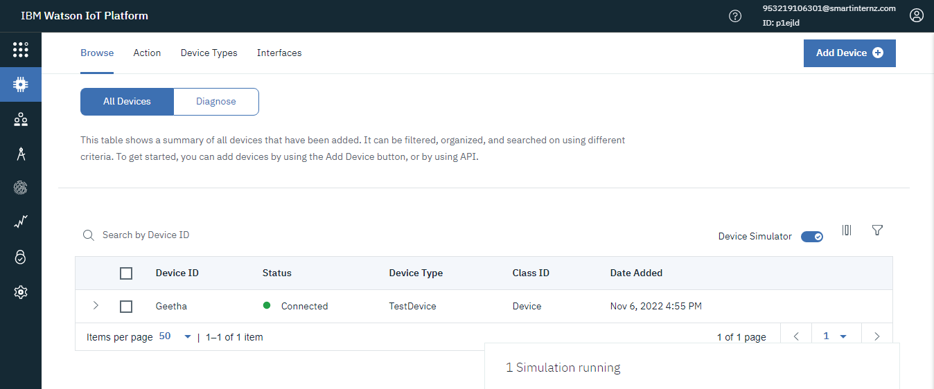

Python code to monitor parameters:

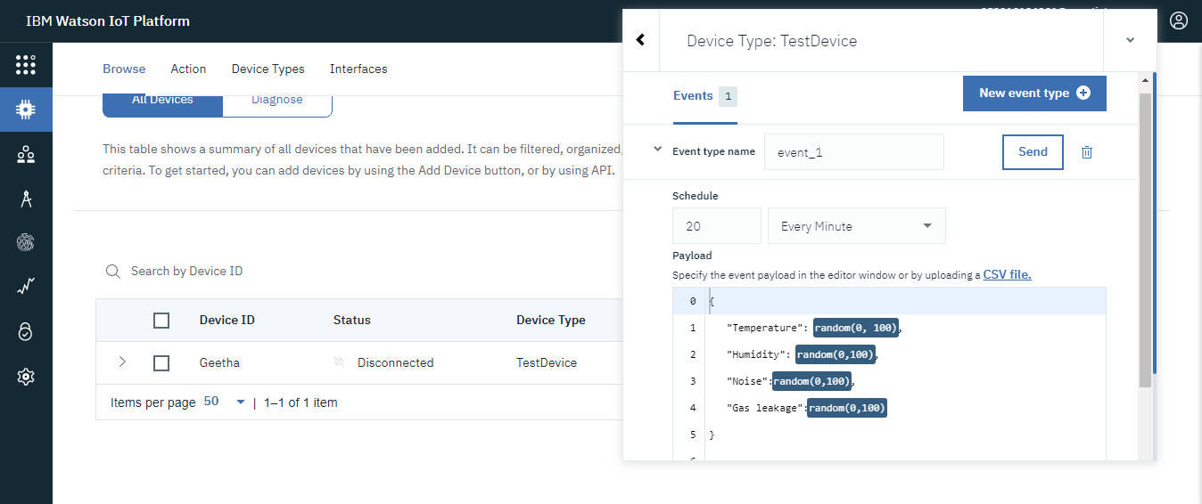

We have generated the parameters to be monitored.

